HR Resume Analyzer Chatbot - Project Report

1. Project Overview
This project is a web-based chatbot that allows users to upload their resumes (PDF), optionally add a job description, and receive analysis powered by a large language model (LLM). The user receives tailored job title suggestions, a resume score, and resume tips. Additionally, users can interact via chat with the HR bot. The system is built using Streamlit, OpenAI APIs via OpenRouter, SQLite for data persistence, and PyMuPDF for PDF parsing.

2. System Flowchart
The following diagram illustrates the main flow of the resume analysis pipeline:
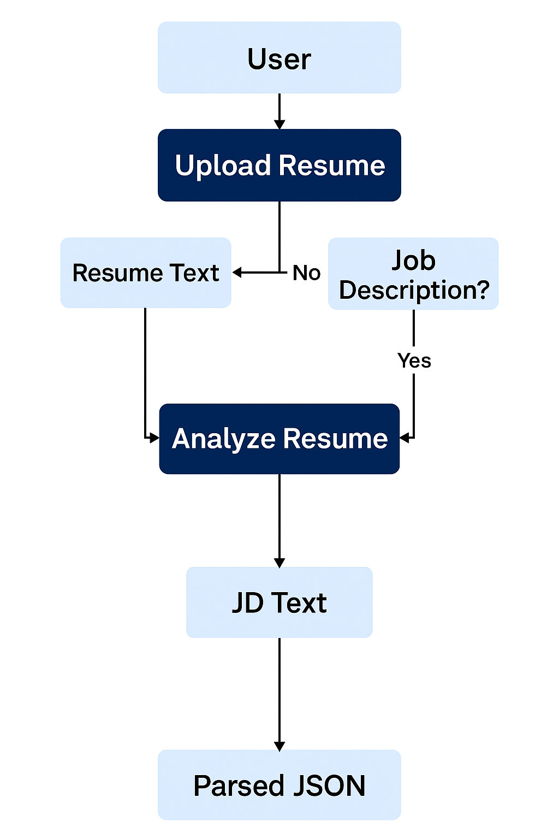

3. File Structure & Functionality

3.1 .env
Contains API key and endpoint for OpenRouter integration.

3.2 app.py
Main Streamlit app. Handles UI, session control, file upload, and routing. Integrates with resume analyzer, chat memory, and authentication systems.

3.3 auth.py
Implements user registration and login using SQLite. Passwords are securely hashed using SHA-256.

3.4 chat_memory.py
Stores and retrieves chat logs in SQLite for persistent chatbot interaction history.

3.5 resume_parser.py
Extracts plain text from PDF resumes using the fitz library (PyMuPDF).

3.6 resume_analyzer.py
Handles LLM prompt creation and OpenRouter API calls. Supports both general and job-specific resume analysis.

4. Features Summary
- User Authentication (Login/Register)
- Resume & Job Description Upload
- LLM-Powered Resume Analysis
- Interactive HR Chatbot
- Chat History Management
- Clear Chat Button

5. Recommendations
- Add file validation (e.g., valid PDF)
- Encrypt databases for sensitive data
- Move API keys to secrets.toml for production
- Provide resume templates
- Implement session timeout

